ONLINE SUNDAY SCHOOL PRE-SESSION PREPARATION
for Sunday, May 27

I. INTRODUCTION:
This Sunday will be unlike anything we have done in our online sessions until now. There will be no teaching, no video, and no music. The plan is to take what we have focused on the past six weeks and begin laying a foundation for outreach into our community.

II. RECAP OF THE PREVIOUS SIX WEEKS
- April 12 (Easter Sunday) – The primary thrust of the lesson, which was repeated intentionally numerous times, was the good news of the Kingdom is the death, burial, and resurrection of Jesus Christ. When we speak of sharing the “good news” or the “gospel” we are speaking of telling others that Jesus died, was buried, and was resurrected for their sin.
- April 19 – We contrasted Shade Tree Churches and Fruit Tree Churches and ultimately determined that God’s desire is that we not only provide sanctuary, but we are called to disseminate the gospel. And we concurred with Dr. Tim Tennent’s quote, “The church of Jesus Christ is God’s plan to manifest His presence and to demonstrate the fruit of His holiness in the world.”
- April 26 – In the first few minutes of the lesson, Mike Cantrell had us focus on the Great Commission found in Matthew 28:18-20. He reminded us that the key here is that we “teach people to do what He says.” This is how we believers are to live our lives. This is also at the crux of fulfilling our calling to go and make disciples.
- May 3 – Brian Clark reminded us that revival happens on many levels, one of which is Awakening. He said, “Awakening is when people who are not believers are awakened to the presence of God in their midst and they are drawn to Jesus Christ as their Lord and Savior. As they see the work of God around them, they are drawn to Christ and His gospel message.”

- May 10 – Rodrigo Cruz presented us with an example of a church willing to go beyond itself for the sake of the gospel. A church even willing to close its doors on a Sunday morning in order to reach the community around them.

- May 17 – Brian Russell suggested that we should read the Bible from a missional perspective. He said, “The core of what it means to read the Bible missionally is to announce the Kingdom─ to call persons already seeking after God to realign their lives with a Kingdom vision and simultaneously call persons who have never moved towards God to come and align themselves with what God is doing with His Son, Jesus, through the power of the Holy Spirit.”

III. THIS SUNDAY’S PREREQUISITE INFORMATION
So, in week seven, we want to see how we can take the lessons of the past six weeks, all of which focused in some respect to outreach, and apply those lessons to outreach in our community. To do that we will use a model for outreach that consists of four components as shown in Figure 1. In this model, the four components are applied simultaneously.

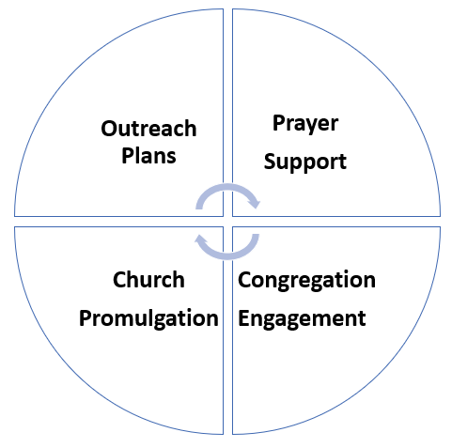
Outreach Model
Figure 1
- Outreach Plans – Develop and implement plans that specify unsaved/unchurched groups to reach, methods of how to reach them, and partners that can assist.
- Prayer Support – Build a support model for outreach that includes pre, present, and post prayer for all outreach efforts of the church.
- Church Promulgation – Evaluate the extent to which the church is known in the community and develop plans to increase the community’s awareness.
- Congregational Engagement – Cultivate a missional mindset within the congregation such that all will engage at some level in outreach.

Outreach Area
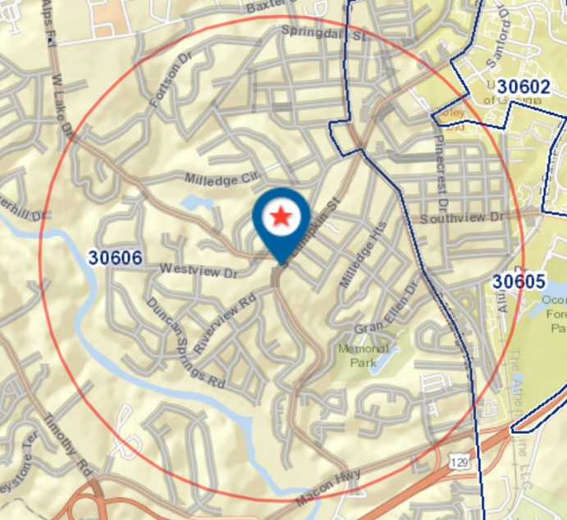
Using Acts 1:8 terminology, Pastor Bill and his staff have designated the area roughly within a one-mile radius of St. James as our Jerusalem (Figure 2). Within this area, there are over 5,000 resident mailing addresses and over 100 businesses.
Figure 2
Although we are concerned with getting the gospel to the greater Athens area, our focus this Sunday will be on our Jerusalem. Also, in the context of this Sunday’s activities, our Jerusalem and our community will be synonymous. So, everything in the circle to the right is our Jerusalem or our community.

IV. THIS SUNDAY’S IN-CLASS ACTIVITY
Using the Outreach Model, we will divide participants into groups. Each group will then address one set of three questions below. You should, if possible, print a copy of this document, especially the questions below, to have with you during class time on Sunday. Also, each group will need to assign at least one person to record the group’s response to each of the three questions posed.
We hope to have 25-30 minutes for the group breakouts and then 10-15 minutes to re-group and give feedback.

The Questions:
Set 1 – Outreach Plans
- Q1 – What are some of the felt needs within our Jerusalem?
- Q2 – What are some spaces or venues in our Jerusalem where we could best interact with people?
- Q3 – What are some of the barriers we would need to overcome to do outreach in our Jerusalem?
Set 2 – Prayer Support
- Q1 – What would be some of the elements of prayer support leading up to an outreach event?
- Q2 – In what ways could St. James use prayer as active outreach?
- Q3 – Given that our outreach efforts will, through the Holy Spirit, produce new believers, how can we use prayer to support these new believers?
Set 3 – Church Promulgation
- Q1 – How well do you think our community knows St. James UMC?
- Q2 – If anything, what is St. James known for in our Jerusalem?
- Q3 – What are some of the ways we could increase community awareness of our church?
Set 4 – Congregational Engagement
- Q1 – What barriers would St. James face adopting a go-to our community mindset?
- Q2 – How well equipped are we to go-to our community? In other words, are we trained for mission and, if not what should that look like?
- Q3 – What can the pastor and staff do to encourage outreach involvement by the congregation?

Note: The activities of today’s online session are not just an exercise. Your responses will go a long way toward helping the church formulate plans and actions that will change the way we do outreach.

